Background

Problem

Goals

Key Features

Success Metrics

Target Market

Core UX Flow

Acquisition Channels

Marketing Guide

Pricing Strategy

Pre-Launch Checklist

Possible Risks and Mitigation Strategies

Training Guide for Sales and Customer Support

User Guide

A/B Testing

Internal Launch Email

### Background

LinkedIn is the world leader in the professional networking ecosystem. With our motto of “Connecting the world’s professionals to make them more productive and successful”, it is an utmost priority of LinkedIn to remain relevant for the new and old generation alike. However, our professional networking platform provides a well suited plethora of opportunities to experienced professionals but has a set back for recent college graduates. So we are willing to expand our job search market for recent graduates by recommending them best suited jobs based on their skills and preferences

.

### Problem

* India contributes 10% of the customer base but less than 2% of revenue comes from India. So one of the aims is to expand the possible market.
* New graduates form the bulk of this market but find it difficult in searching opportunities.

### Goals

* AI powered Resume Builder with keywords and phrases that would help them with shortlisting in companies.
* Smart job recommendation based on their skills and preferences.
* AI interviewer to help them with mock interviews and suggestions.
* Skill enhancement and career path suggestions.
* Expert mentor guidance program from industry leaders.

### Key Features

|  |  |  |
| --- | --- | --- |
| **Priority** | **Feature** | **Description** |
| P0 | AI based Interviewer. | An AI model trained with various Q/A asked across several companies and provides feedback based on pre-trained model. |
| P0 | Video Interview Pipeline | A robust video recording platform for users to submit their mock interview recordings |
| P0 | Interview Feedback Engine | AI driven feedback algorithm that analyses users’ interviews and identifies strengths, weaknesses, areas of improvements and associated contents to refer |
| P0 | Data Privacy Policy | Terms and conditions that allow users to know how their data is being stored and option to customize accordingly. |

|  |  |  |
| --- | --- | --- |
| P0 | Content/Mentor Recommendation Engine | AI driven recommendation algorithms that crunches data from users’ resume, goals, interests, skills, AI feedback engine’s reports and mentor/content interactions to suggest users new content for upskilling |
| P1 | Audio Interview Pipeline | An audio recording platform similar to video platforms for recording user interviews at lower latency and lower data speeds. |
| P1 | Text Interview Pipeline | A chat based application for users to reply to specific interview questions to get feedback at extremely low latency and lower data speed. |
| P2 | AI Based chatbot mentor. | An AI model that can guide you as efficiently as a mentor and is available for help round the clock. |
| P1 | Company engagement | Connecting employees from industry for giving an insight into work culture, responsibilities of various roles, perks , vision etc. |

### Success Metrics

1. Increase in conversion of subscription by 2%
2. Targeted average time to first job application ~2 days and first job landing ~ 1 month
3. Targeted play store rating increase to 4.5/5
4. Outage reduction by 50%

### Target Market

* We will focus mainly on **Indian Market**.

Reasons :

* 1. Second largest market with 66M users.
  2. Highest graduate growth rate.
  3. Highest Youth population in the world.
* There are two set of audiences that we are targeting, the ideal customers and the ideal experts, each of which are analyzed below:
  + Customers:
    - Target audience: New graduates and to-be graduates between the age of 18-29who are about to complete their graduation and enter the job market
    - Target market: India
    - Possible channels: Social Media, Universities, Educational content providers, Newspapers, Magazines
  + Experts:
    - Target audience: Industry leaders and employees, experts from academia and research fields, entrepreneurs and other established members
    - Target market: Both India and International
    - Possible channels: LinkedIn, Twitter, Social media, Universities, Industries.

TAM = Number of new grads in India/year * Monthly subscription price * 12

= 20M * $20 * 12 = $4.8B @2.35% growth rate YOY

Assuming **10%** of **Number of new grads in India/year** subscribes, the revenue would be **$488M.**

Marketing + Product Development + Other costs = **$100M (say)**

**ROI = Profit/Costs ~ 3.88**

* LinkedIn’s major competitors are Naukri, Indeed, Shine, MonsterIndia and a bunch of startups like Amcat, elitmus, cocubes, TopHire etc.

Analysis of Top competitors to find the user base, revenue and market share captured is as follows:

* + - 1. Naukri :
         1. #Users: 50M
         2. Online Traffic: 18M
         3. Revenue: $65M
         4. Market Share: 55%

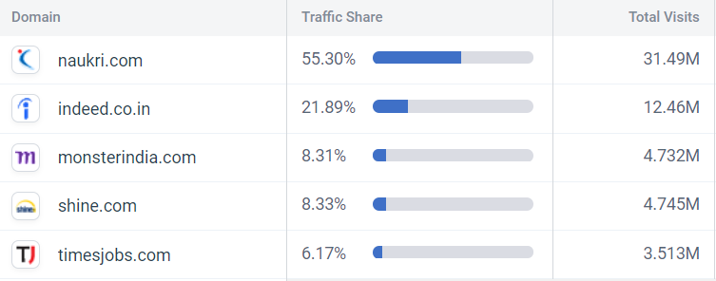

* + - 1. Indeed :
         1. #Users: 20M
         2. Online Traffic: 12M
         3. Revenue: <$30M
         4. Market Share: 21.89%

### Core UX Flow

**Storyboard**: <https://drive.google.com/open?id=1DZkqdST7wSydKETijqOqn9caZfpi4IoU>

**Mocks**: <https://www.figma.com/proto/IYSvzps5ob6vifv6QFnmpx/v2?scaling=scale-down&node-id=2%3A160>

### Acquisition Channels

|  |  |  |
| --- | --- | --- |
| **Channel** | **Description** | **Why does it work?** |
| Android Play Store/iOS App Store | The app downloads for LinkedIn happen from these two major places, with Apple and Google often highlighting top apps as Featured/Editor’s Choice etc. | With appropriate SEO, users can land on the app on the App Store/Play Store by searching terms like “professional”, “new graduates”, “interviews”, “jobs for freshers” etc. |
| Social Media Campaign (Facebook/Instagram/Twitter) | Digital Marketing on social media platforms for better outreach. | Most new graduates from age 18-25 can be usually found using various social media platforms |
| College/University Noticeboards/Training and placement officers/ Campus Ambassador program/ College fest | Noticeboards are used by universities to announce important information for students and campus ambassadors act as a bridge between company and campuses. | Since most new graduates and to-be graduates are connected with their university notice boards for important information regarding colleges, reaching out to them via this channel would be effective.  Campus ambassadors can be effective to market our product without much investment which can be utilized further to sponsor various events and fests in colleges for better outreach among students. |
| Education Content Providers (Bloggers/Youtubers/Motivational speakers/Sites) | Many education content sites, bloggers and Youtubers exist who create content for helping students/new graduates understand educational topics better | Since most of the new graduates/to-be graduates are found at such platforms for studying/upskilling, this would again be a good channel to reaching to our target customers |

### Marketing Guide

Marketing Guide: <https://docs.google.com/document/d/1wKmovVqtNWwDEF1tdijSpvZeaJ1xGraq6ZFpBG371oU/edit?usp=sharing>

### Pricing Strategy

There are many competitors of linkedin who charge hefty amounts from students either by charging fees upfront (in the range of Rs. 15000-30000 ) or on the basis of income sharing agreement ( in the range of 50000-2lakhs ) for upskilling them and preparing them to land in a job often of not their choice. We wanted to make “LinkedIn Freshers “as affordable as possible which made us come up with the following plan -

|  |  |
| --- | --- |
| **New Grads** | **Expert Mentors** |
| * Premin Subscription for new graduates with access to unlimited mock interviews, practise tests, courses on LinkedIn Learning, expert mentor guidance and all upcoming features all at a minimal rate of Rs. 3999/ annum. * Gold Subscription for new graduates with access to 100 mocks interviews, unlimited practise tests ,access to only recommended courses based on his skills and interest in Linkedin Learning and option to any 20 expert mentors all at a rate of Rs. 1299 per annum. * Free tier with access to 2 mock interviews per month, unlimited practise tests, free courses in linkedin learning and the option to choose any 5 expert mentors. | * Free registration by mentors for providing mentorship * Revenue sharing agreement with LinkedIn for fees charged on mentoring. |

### Pre-Launch Checklist

Apart from scrum team consisting of engineering, design and QA members, these are the following partner teams with whom collaboration is needed to successfully launch and land the new product feature for LinkedIn:

|  |  |  |
| --- | --- | --- |
| **Partner Teams** | **Purpose** | **Collateral Materials** |
| Sales & Marketing Team | Outreach to experts for mentorship and content creators/universities/social media channels for publicity | Sales and Marketing Guide with product vision, value proposition and target markets |
| Customer Support Team | Help answer user questions and queries | Technical Guide with current features, possible bugs and walkthrough |
| Technical Writing Team | Create release notes for feature launch and user guides for new users | Help center information and articles |
| Product Specialist Team | Assist customer support teams with feature understanding, walkthroughing with user problems and creating tickets for new bugs | Technical Guide with current features, possible bugs and more in depth walkthrough and mitigation strategies |
| Data Analyst Team | Help track metrics and KPIs | List of essential metrics with their priorities, targets and possible trends |

### Possible Risks and Mitigation Strategies

|  |  |
| --- | --- |
| **Possible Risks** | **Mitigation Strategies** |
| UI might be unresponsive in old phones/low priced phones | Test out UI with QA teams on major possible phones used by target audiences before launch and accordingly create feature flags to make the service available only on select phones |
| AI mock interview service might get overloaded hence becoming unresponsive/leading to crashes | Work with engineering teams to understand the load levels that the internal servers and AI services can deal with without breaking down and accordingly plan a gradual rollout |
| Reach Out to partners might be delayed due to which after launch, significant number of users do not onboard. | Strategize beforehand with marketing teams on how to create and onboard partners for better reach out by collaborating with them from the start of the sprints and maintaining a feedback loop. |
| Mentors are unavailable for help after launch leading to poor feedback/longer waits | Collaborate with sales team to create a roadmap and share during onboarding the mentors and experts regarding their participation just after launch for better services, and create an internal expert team for providing mentorship services to new users in case of failure |

### Training Guide for Sales and Customer Support

**Training Guide:** <https://docs.google.com/document/d/1xFZCxH47TvdNWHqq9eTXceHaX6bNW1gQmC1wZEJImBo/edit?usp=sharing>

### User Guide

**User Guide:** <https://docs.google.com/document/d/1w7ArSwWupD5O2JMfW6OFgdWK6XO9RA7IB_KFAlpKcXs/edit?usp=sharing>

### A/B Testing

As can be seen from the data, the adoption rate is lower than expected and the active users are even lower.

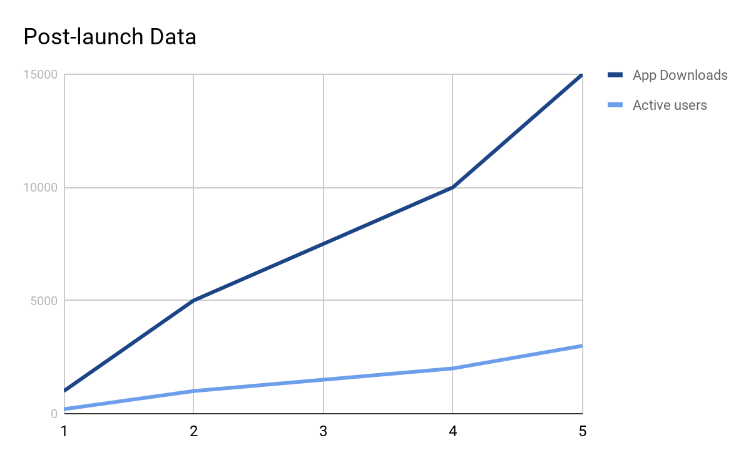

* **Potential problems include**:
  + Platform is not engaging
  + Mock interview session takes a lot of time for user to conduct
  + Mentors are unresponsive/not effective
* **Proposed solution**:
  + Users may find the platform less engaging as initially there are less interactive sessions and industry connects. Increasing more industry connects, holding more live motivation sessions, inspirational videos, company interview experiences videos and hackathons and competitions with exciting prizes will help to attract more users.
  + It is highly probable that the users are finding mock interview sessions time taking and difficult to conduct as they might have to find relevant questions, compute and process the response for them which is a time consuming and resource intensive process. So the proposed solution is to create curated interview playlists based on some specific job/skill/topic/company so that users can run through all of them and get an insight into the type of questions asked and how to answer those questions just like a regular interview.
  + More mentors should be onboarded on the platform and their performance needs to be monitored based on feedback and create an internal expert team for providing mentorship services to new users in case of failure or unavailability of mentors.
* **Success metric to be used**: Daily Active Users (DAU)
* **A/B Test parameters**:
  + Group A: Do nothing
  + Group B : Suggest an “ Interview Playlist” of pre-recorded interview experiences for different roles/topics/skills and companies.
* Our hypothesis is that the curated interview playlists will make it easier for users to understand the type of questions asked in different interviews and the kind of answer that the interviewer expects, which will subsequently lead to higher DAU for users in Group B.

### Internal Launch Email

**Launch Email:** <https://docs.google.com/document/d/1HbdNm87mzKjk_Us-4LRUF4TyZFRSxMpVgKFzb8o6WVE/edit?usp=sharing>